**MAIN ASSIGNMENT DOCUMENTATION:**

**MILESTONE1a**:

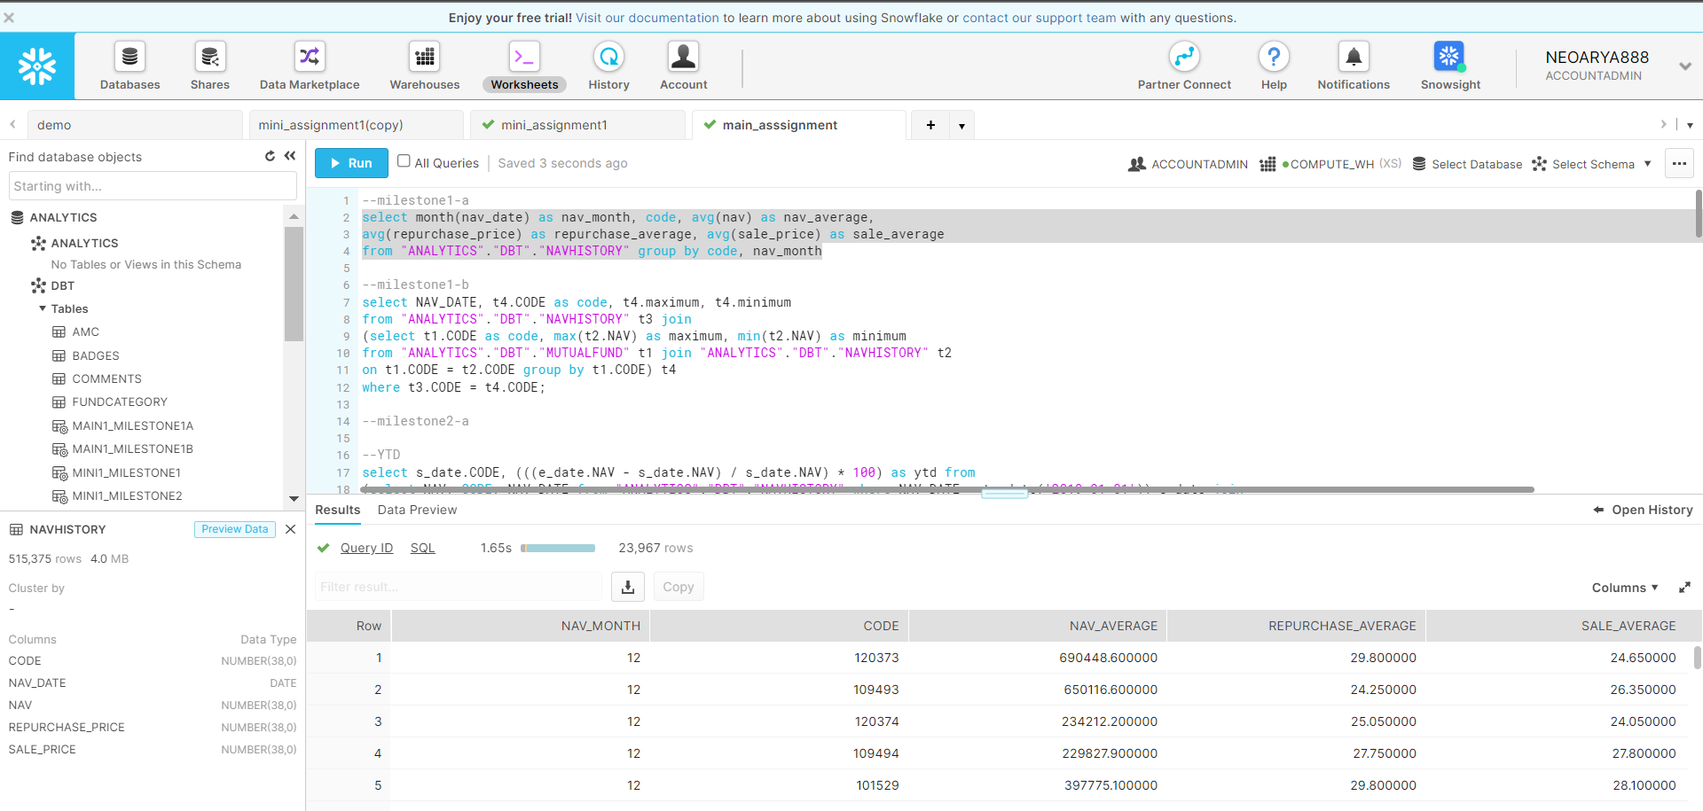

**MILESTONE1b**:

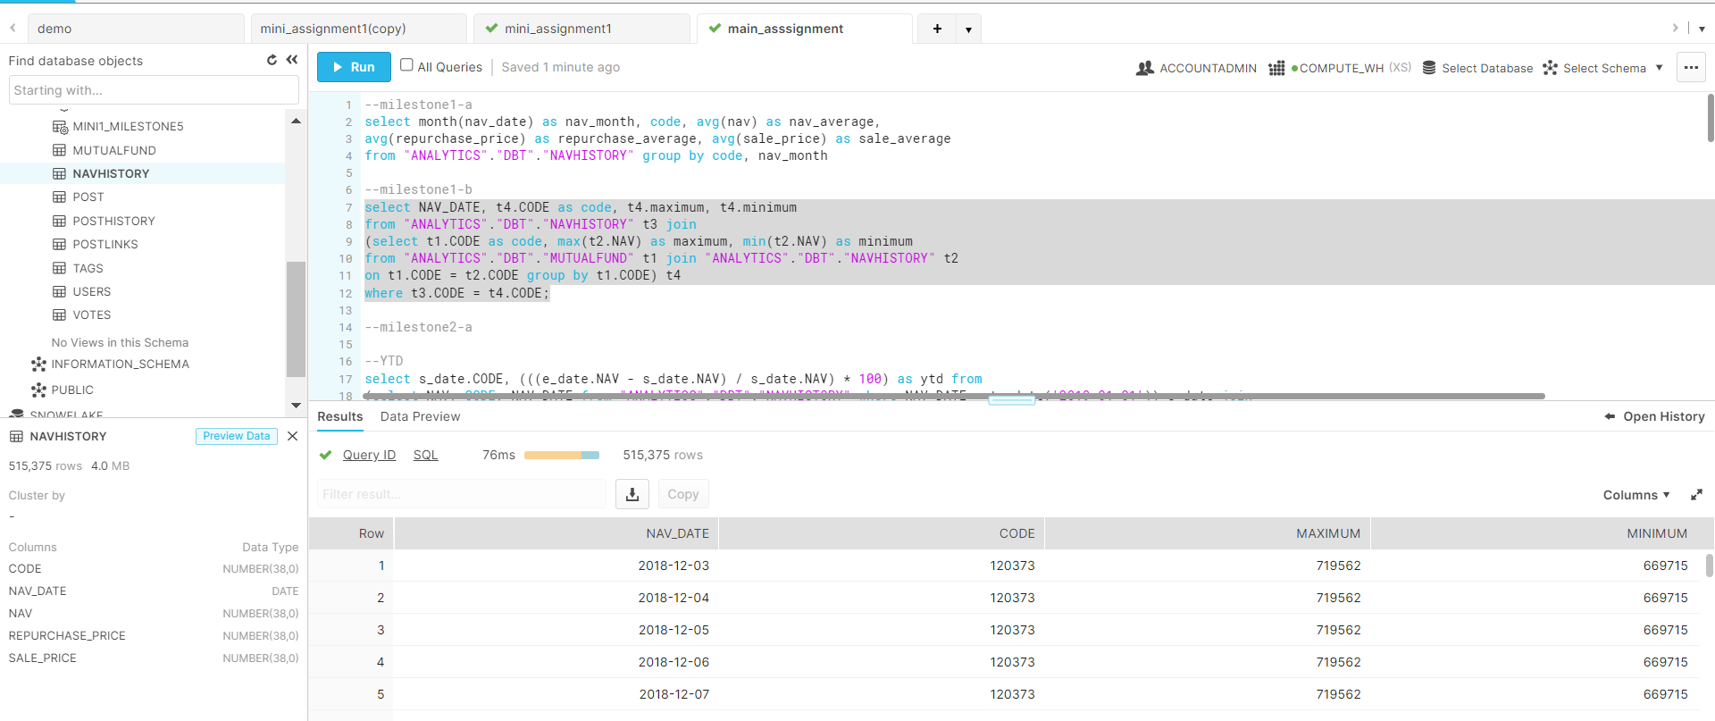

**MILESTONE2_1**

-YTD

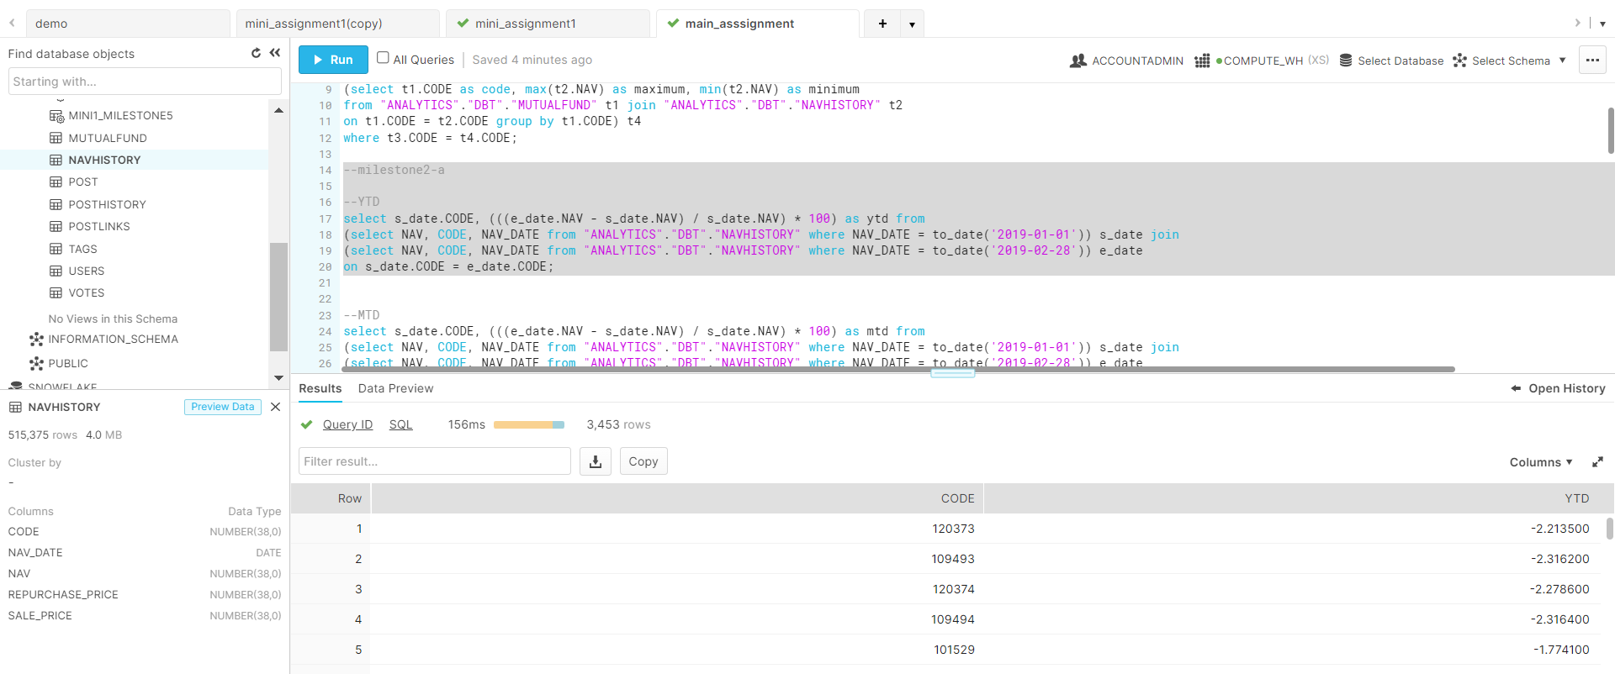

-MTD

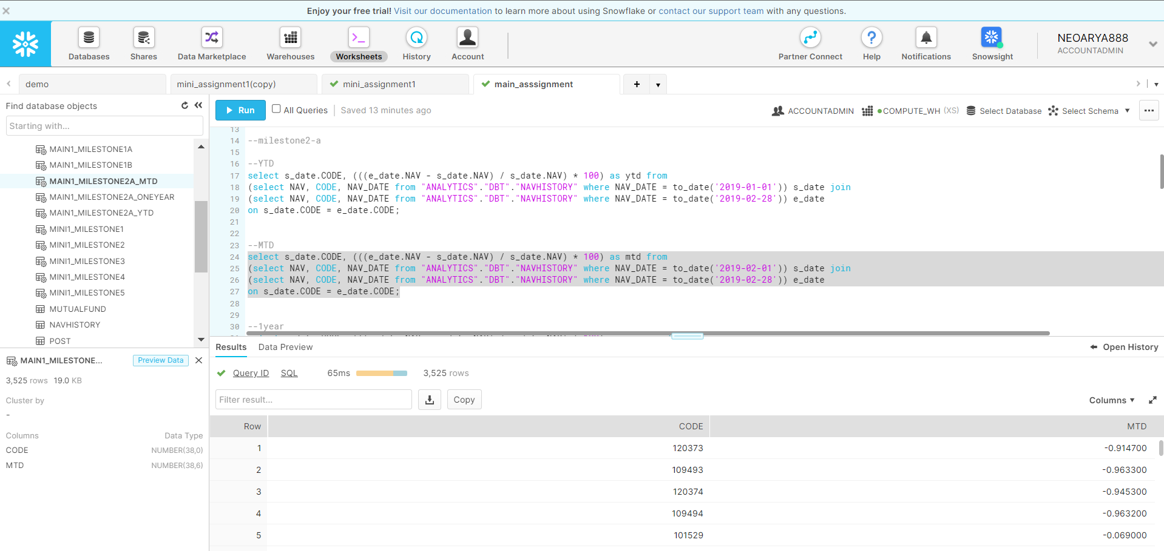

-1year

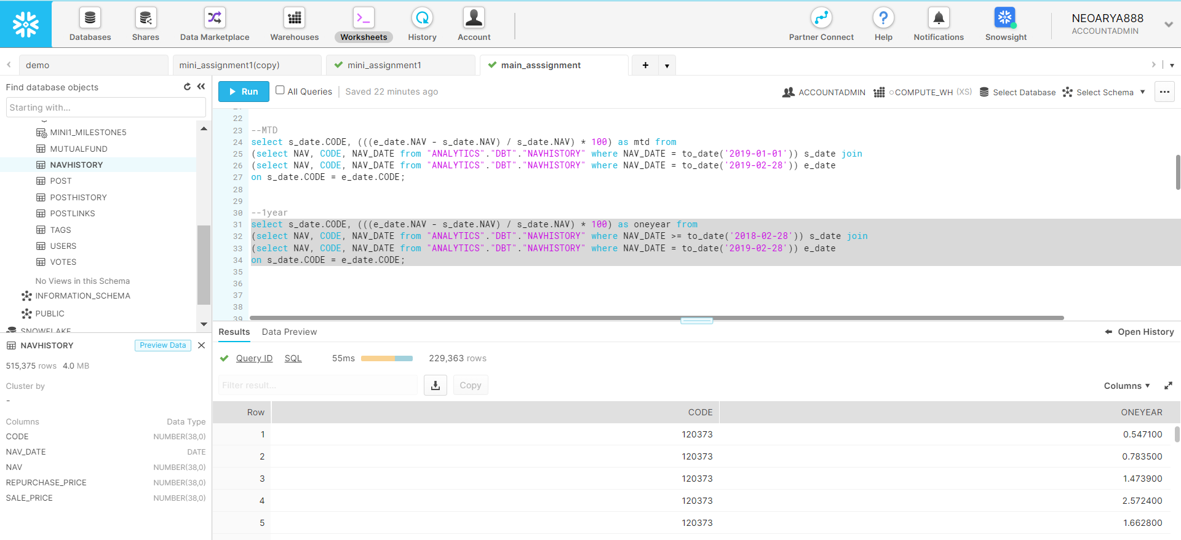

**MILESTONE2_4**

APPROACH: Can be similarly done like milestone 2_1, by adding extra having statement as: “HAVING LIKE ‘%liquid%’ ”, but I was not able to join 3 tables i.e mutualfund_table, fundcategory_table and navhistory_table. So, getting error.

**MILESTONE3:**

**Google Data Studio Link:** https://datastudio.google.com/reporting/c196d48c-8786-46e9-9848-819797c6772a

1.

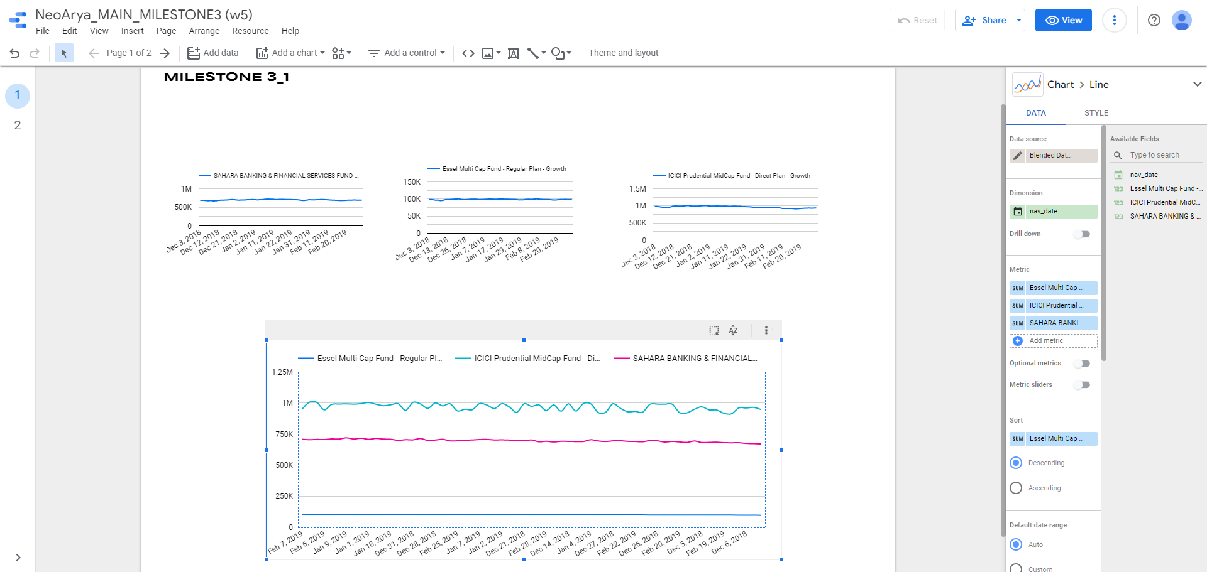

3.

APPROACH: I have added an extra query also to get the mutual funds csv with category name, as in raw mutual fund csv, the labels were filling with its code. This is done to increase visualization of required date.

The query applied is :

select mu.code,mu.name,mu.category_id ,fc.category from "ANALYTICS"."DBT"."MUTUALFUND" mu, "ANALYTICS"."DBT"."FUNDCATEGORY" fc where mu.category_id = fc.id;

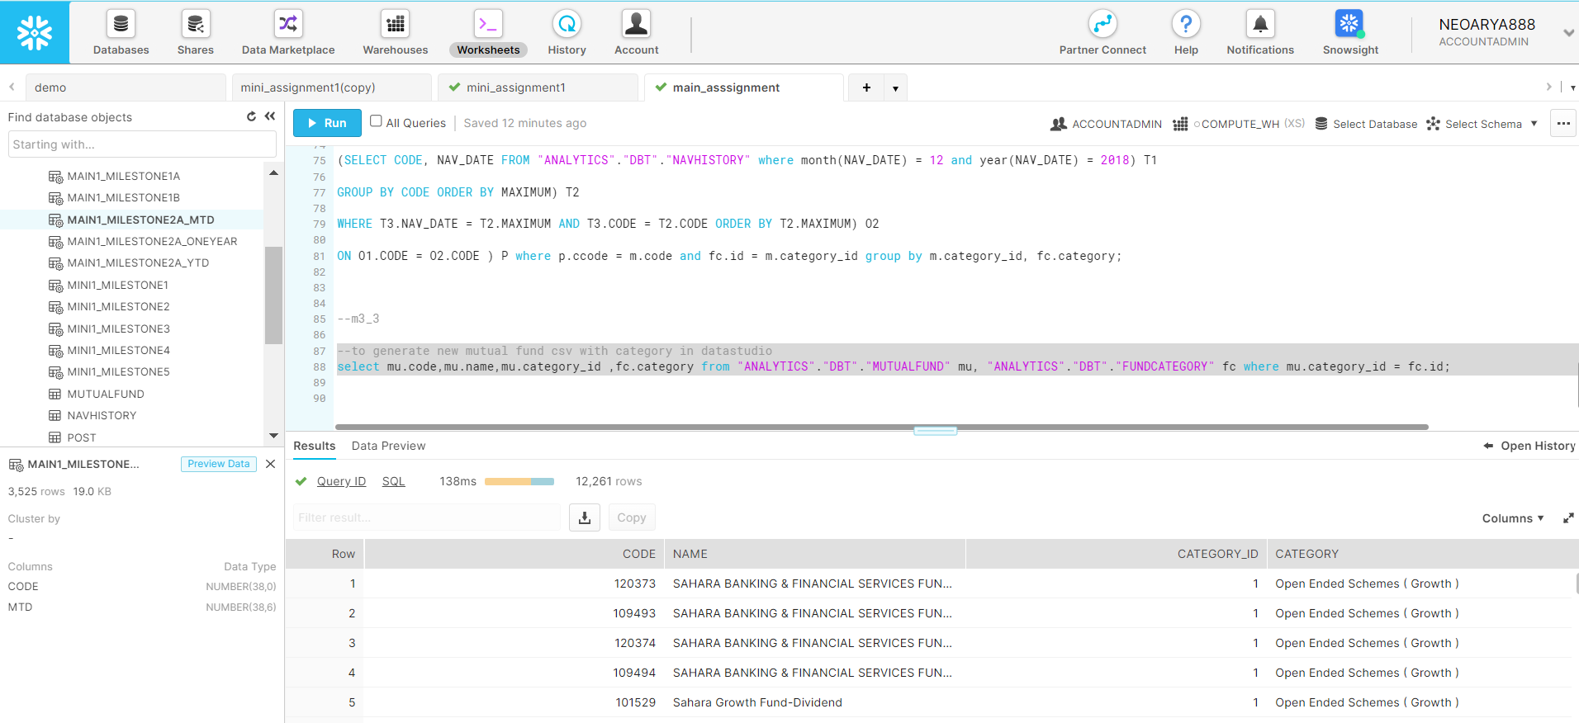

After inserting query and getting updated csv, the pie chart can be visualized as below

